# Typescript Basics

Typescript is typed superset of javascript that compiles to plain javascript.Typescript is pure object oriented

Typescript file with .ts extension

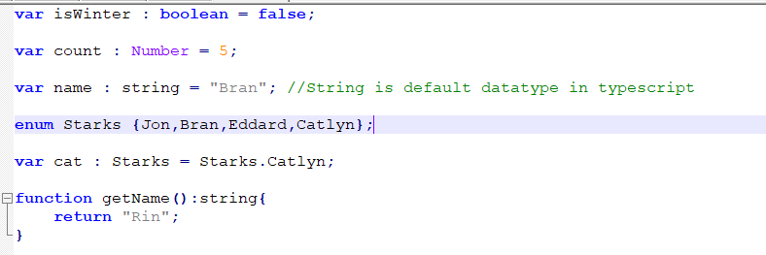

After compiling this it creates javascript code

Javascript file with .js extension

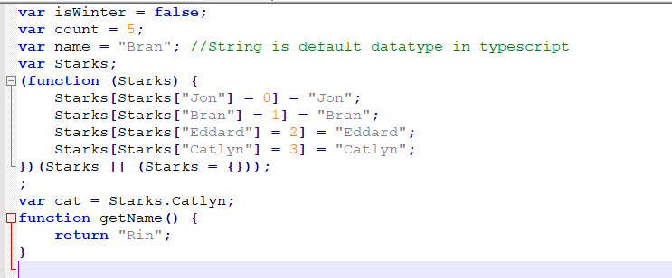

## **The Benefits of Using Typescript :**

* Due to the static typing, code written in TypeScript is more predictable, and is generally easier to debug.
* Makes it easier to organize the code base for very large and complicated apps thanks to modules, namespaces and strong OOP support.
* TypeScript has a compilation step to JavaScript that catches all kinds of errors before they reach runtime and break something.
* The upcoming Angular 2 framework is written in TypeScript and it's recommended that developers use the language in their projects as well.

**Classes and Features:**

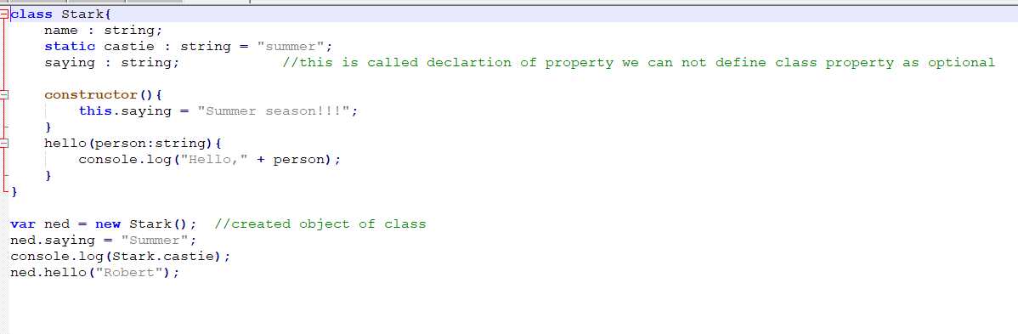

First Hello World Program :

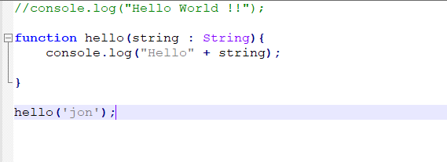

**Inheritance in typescript :**

Like we have inheritance in object oriented same we way we inherit the class in typescript

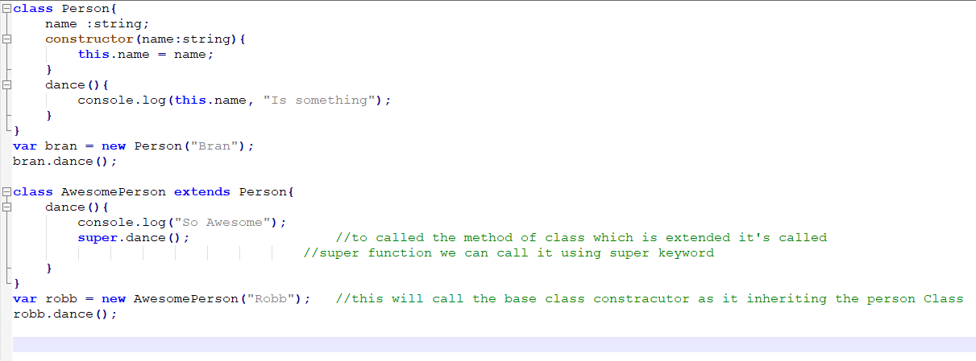

In above code class AwesomePerson inherit the class person and to call the dance method of base class we use super keyword.

**Interface in Typescript :**

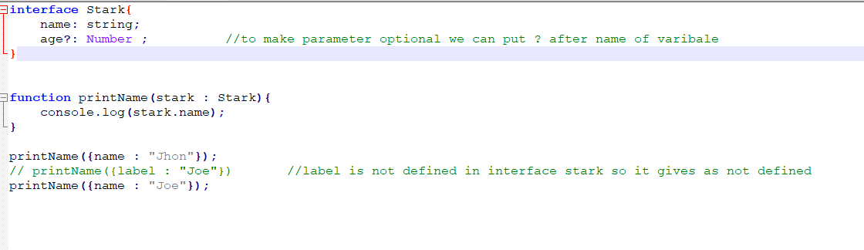

In interface to make the parameter optional we can use ’?’ after name of variable.

**Modules in Typescript :**

Modules are executed within their own scope, not in the global scope; this means that variables, functions, classes, etc. declared in a module are not visible outside the module unless they are explicitly exported using one of the [export forms](https://www.typescriptlang.org/docs/handbook/modules.html#export). Conversely, to consume a variable, function, class, interface, etc. exported from a different module, it has to be imported using one of the [import forms](https://www.typescriptlang.org/docs/handbook/modules.html#import).

In below code there is a module which contain export class useful

